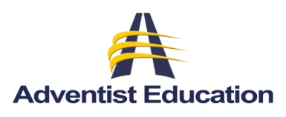
Seventh-day
North American Division
Office of Education
12501 Old Columbia Pike
Silver Spring, MD 20904
301.680.6440
education@nad.adventist.org
Adventist
Church

The IDEAL School Board member is:

- A committed, Spirit-led, Seventh-day Adventist Christian

- Faithful to God as a good steward

- A firm believer in, and supporter of, Christ-centered education

- Committed to upholding the school’s students, staff, and mission in their prayers

- Willing to represent his/her church to the school, and also willing and eager to represent the school to his/her church and church board

- Credible with the local church, one whose opinions and counsel are listened to with respect by the church members, board, and staff

- Willing to support and promote an active Student Aid program in his/her church

- Willing and able to actively support, and encourage others to support, the regular and special needs of the school, its students, its staff, and its mission

- Willing and committed to give not only board meeting time and energy, but also actively participate in board-related committees and special activities

- Committed to be prepared for committee and board meetings, including study of materials sent in advance of meetings

- One who has special talents or knowledge in the areas of group leadership, law, business, financial management, human relations, education, building construction and maintenance, or other disciplines essential to informed review and formation of the policies by which the school operates

- Committed to honoring all constituency, board, and committee meeting appointments

Adapted from; Pacific Union Conference, North American Division

