Quarterly Portrait
Assessment Instructions

Photocopy this template for each child at the beginning of the school year. In the month of August/September, have each child draw a picture that represents themself, a family member, or another person (ex., Bible character, friend, relative, etc.). Repeat this activity at the end of each quarter (Oct, Dec, Mar, and May). Place the finished portrait drawing in the child’s portfolio in the “Work Samples” section. The growing collection for each child should show their developmental progress throughout the school year.
Optional: If preferred, or simply for the fun of variety, allowing the children to draw portraits on a chalkboard or whiteboard and taking close-up photos of the portrait drawings, printing them, and keeping them in their portfolios is also good.
These quarterly portraits will assist the teacher in tracking the developmental progress of each child.

Developmental Stages of Children’s Drawings

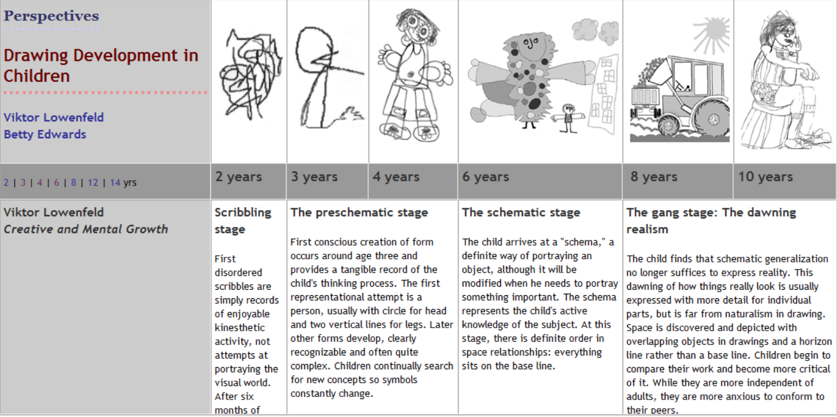

Quarterly Portrait
Child’s Name:______________________________________________ Child’s Age: _______-________
Years Month
Circle Month: Aug-Sept / Oct / Dec / Mar / May

Note here the child’s verbal description of the portrait picture:
____________________________________________________________________________________
____________________________________________________________________________________

