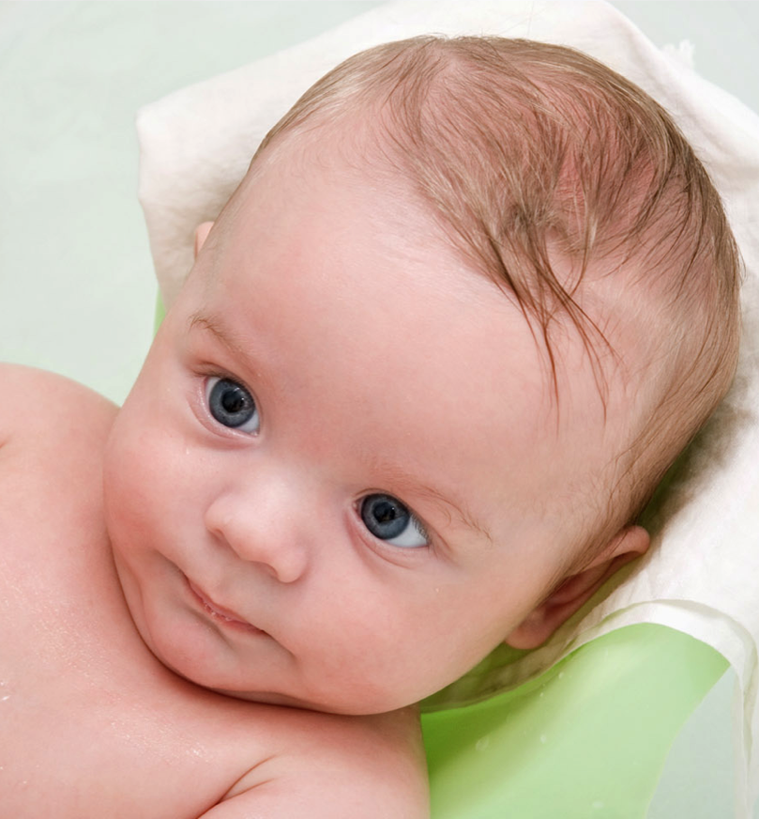


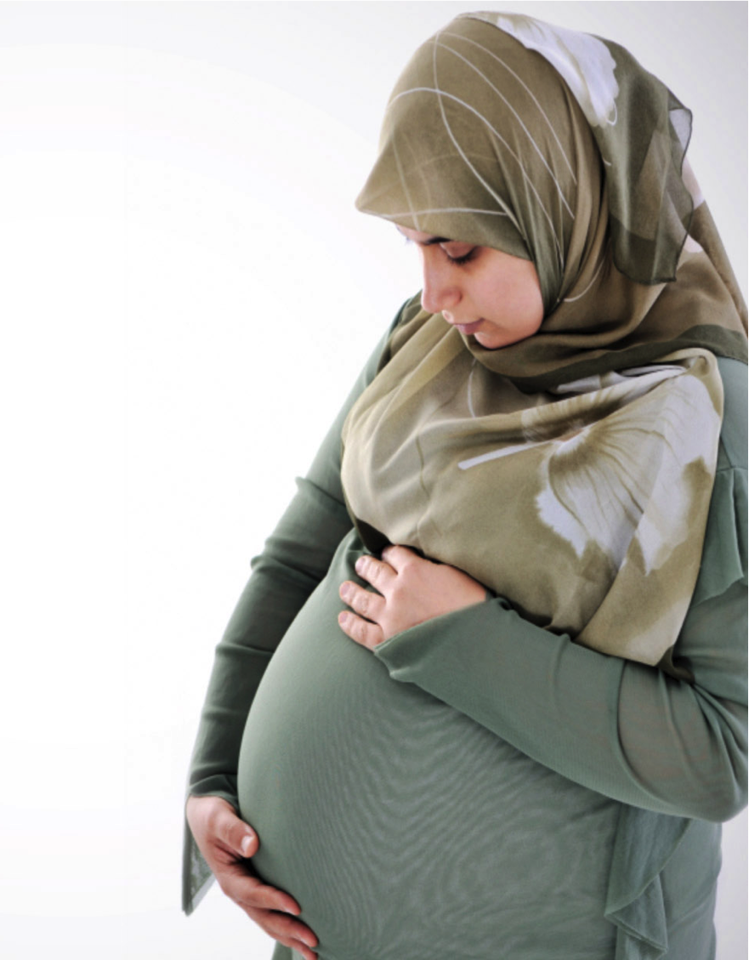





Companion
In a fascinating 11-session course, learn how to be a birth companion for a pregnant young woman
Childbirth is one of the most amazing events in a woman’s life. With the love and support of her husband, she will find that bearing a child helps to grow their relationship.
However, a young woman may need the emotional support of another woman during her pregnancy. Not everyone has a mother or relative nearby to take that role.
You may just the right person!
Be a Comforting Presence
For a Friend

Learn how to accompany a young woman through pregnancy
A birth companion is a woman of experience who trains to be the emotional and friendship support a young woman may need during pregnancy. She does not take the place of a supportive husband but accompanies the pregnant one as only a woman can.

During pregnancy, most women feel the need for a female companion to walk with her through her pregnancy. You can learn how to become a birth companion in only 11 sessions!

Sign up today!
  - Birth
What Is a Birth Companion?

Seminar
Seminar information:
[address] [phone]
[email, web] [how to sign up]
[date]
Among the topics of the 11-session
Birth Companion seminar:

- Learn how to be confident in your knowledge of the birth process and the events surrounding it.

- Train to be able to offer appropriate supportive responses to different situations.

- Learn ways to understand the place for this supportive role without negatively impacting the marriage relationship or the patient-and-care-provider relationship.

“Be a loving presence for a young woman.”
Increasing numbers of women face childbirth without a strong supporter to help them get through. A birth companion to accompany such a woman may make the difference between childbirth being joyful or overwhelming.
For women with a loving and supportive husband, a birth companion is not a replacement at all. That friend is an expression of the confidence a woman has in another woman who can understand the fears, pains, and anxiety related to childbirth.

The Birth Companion seminar was written by Allan Handysides, M.B., Ch.B., FRCPC, FRCSC, FACOG.

BIRTH COMPANION Seminar
How to sign up:
[phone, web, email, etc.]

BIRTH COMPANION seminar takes place on these dates and at this time:

___________________________________
At this location:

___________________________________
Directions: [map]

Encourager, supporter, comforter

